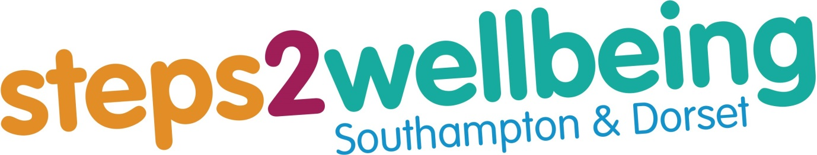

**PLEASE REMEMBER**

Changes take time, patience and hard work.

The more you put in whilst completing the course, the more you get out of it.

**Managing your anxiety**

**Session One**

**Introduction**

Welcome to our managing anxiety course. It is a comprehensive skills-based course that draws from all aspects of Cognitive Behavioural Therapy (CBT) to treat and manage anxiety. We aim to equip people with the knowledge and skills to substantially reduce their anxiety by working on themselves.

* Every week will focus on gradually developing our understanding of CBT for anxiety. It will be like building a jigsaw puzzle and the picture will become clearer as the course progresses.
* We will help people set specific and clearly defined goals for what they want to change about what they are thinking and doing so that they can reduce and manage their anxiety.
* Near the start of each session we will review how people have managed over the previous week and support the development of peoples’ understanding and skills.
* Towards the end of each session we will set home practice for the coming week that will support peoples’ learning.

**Getting started with noticing how you are feeling…**

An important part of CBT is monitoring what is happening in our bodies and minds. Let’s start by thinking about your anxiety right now. Rate your anxiety at being in a group whilst everything is new for you. Where is your anxiety at the moment on a 0-10 scale, where 10 is: “I find it extremely challenging being part of the group” and 0 is “I am very relaxed”? We will ask you to rate your anxiety levels regularly throughout the course, particularly before and after practicing skills.

0

Circle the line with where your anxiety is right now?

|  |  |  |  |  |  |  |  |  |  |
| --- | --- | --- | --- | --- | --- | --- | --- | --- | --- |
|  |  |  |  |  |  |  |  |  |  |

0

2

4

6

8

10

* What do you predict will happen to the ratings at the last group session?

** Keeping Safe Between Sessions**

Steps to Wellbeing is not a crisis service, and although you are welcome to contact the service between sessions, the course facilitators may not be available to speak to you. If you are feeling very low and need some support between sessions, there are a number of places that you can turn to:

* Connections provides a free 24/7 helpline for people needing urgent mental health support. They can be reached on 0800 652 0190.
* Contact your GP surgery and request an urgent appointment
* 111 is a 24/7 service which offers free advice for both physical and mental health concerns
* Go to A&E if you are worried about hurting yourself or someone else
* The Samaritans offer free 24/7 support to anyone in crisis. You can call 116 123 or text SHOUT to 85258 to connect with a trained Crisis Volunteer. Alternatively you can email jo@samaritans.org
* Think of a friend, partner or family member that you can seek support from
* There may be another professional involved in your care who could help, for example your Health Visitor, Social Worker, Support Worker or GP Practice Nurse.

***Please make a note of your useful telephone numbers, so that you have them to hand when you need them. You may want to write them in the space below, or save them in your phone so they are ready to use.***

e.g. my GP surgery

|  |
| --- |
|  |
|  |

**My Personal Safety Plan**

|  |
| --- |
| Signs that my mental wellbeing is deteriorating |
| What would I be:  Thinking:  Feeling:  Doing or not doing: |
| What steps can I take to manage this? Where can I get support? |
|  |

**Ground Rules and Online Etiquette:**

So that we can all have the best experience of the course that we can, there are a number of ground rules that we ask everyone to follow:

**Confidentiality:** Please keep everything that everybody says on the course completely confidential. Don’t repeat it to anyone else. Please attend the online course in a private location in which other people won’t be able to overhear. Please do not record any part of the course.

**Respect and Kindness:** Please don’t comment on what other people share or say in the group unless invited to do so. Please allow everyone the opportunity to speak should they wish to. Please don’t get involved in other activities, such as checking your messages or emails, whilst attending the course. Do your best to be present for everyone.

**Timekeeping:** Please attend on time, and stay for the duration of each session unless you have very good reasons why you have to leave early.

**Attendance:** If you are not going to be able to attend a session, please let us know by responding to the reminder email you received about the course or by phoning our admin team on:

**The Mute Button:** The software we use has a “mute button” that allows you and the trainers to turn your microphone on and off. The microphones on most devices are very powerful and tend to pick up lots of background noise. We ask people to keep their microphones muted unless they are speaking.

**Speaking and contributing:** Please raise your hand if you would like to speak and wait until the trainer asks you to speak before talking. This is to stop us talking over one another, which is easy to do when we use the online format for the course. Nobody is required to talk, and we greatly value everyone’s contributions.

**Other:**

**A little bit about Cognitive Behavioural Therapy:**

**Each of us is unique, but…**

We *all* inherit aspects of ourselves (genes).

We are *all* influenced by our early environments.

We *all* live in a culture that expects certain behaviours of us.

We *all* develop an idea of ‘who we are’ over time, and who we want to be.

We all learn ways of coping with the world we live in.

Much of what we *all* do becomes automatic.

**What is Cognitive Behavioural Therapy – CBT**

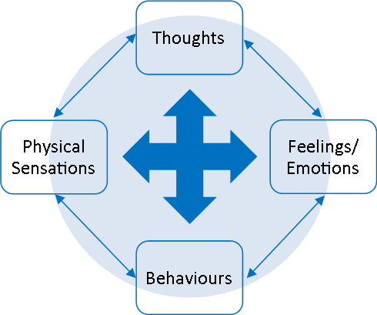

CBT is a talking therapy that focuses on how our thoughts and our behaviours affect the way we feel (physical sensations and emotions).

CBT is a treatment that has been proven to be effective and long lasting for people experiencing common mental health problems, like depression or anxiety.

CBT mainly focusses on the here and now. What is keeping me feeling like this?!

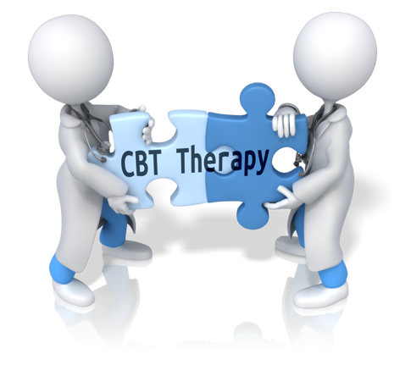CBT focusses on learning practical skills and strategies to help you manage your difficulties, not just now but in the future.

CBT is not something that is done to you. You will get just as much out of it as you put into it.

The first step is coming to sessions, but it doesn’t stop there. CBT requires commitment and practice. A lot of practice!

**An Overview of the Course:**

The course covers a number of different areas and has several “streams” of skills and techniques to reduce and manage anxiety. A brief overview of what we cover is provided below.

We will look at what anxiety is and how we can unintentionally get caught up in cycles of anxiety when we are trying to do what we need to do to feel less anxious.

We will introduce a number of CBT techniques and skills. These include:

* *Life-style factors that help reduce anxiety*
* *Attention Switching*
* *Mindfulness and Acceptance*
* *Mapping out how anxiety is maintained - Formulation*
* *Thinking biases, anxious thinking and changing anxious thoughts*
* *Changing anxious assumptions through behavioural experiments*
* *Understanding and changing cycles of worry*
* *Developing our inner helper*
* *Relapse prevention and management*
* *Planning your next steps*

On the next page we will start with getting a better understanding of what anxiety is and why we all have it.

**What is anxiety?**

Anxiety is something that we all experience from time to time and is a natural response to a situation that we perceive as threatening. The physical response to anxiety is known as the fight, flight or freeze response.

The fight, flight or freeze response is an instinctive reaction that aims to keep you safe and prepare your body to either run away from a threat, fight against it to protect yourself, or inhibit you if fighting or fleeing is too dangerous. It is a survival reaction over which we have limited control.

Regardless of whether your response is to fight or flee, your body needs to prepare for action. This triggers a number of physical changes, including increased heart rate, raised blood pressure, redirection of blood to the muscles, rapid breathing to increase oxygen levels in the bloodstream, release of stored sugars into the bloodstream to fuel the muscles, slowing down of digestion and suppression of the immune system so that the body’s resources are redirected to immediate survival.



The physical sensations we experience include: increased awareness of rapid heartbeat, increased awareness of rapid breathing , which is often accompanied by a feeling of tightness or restriction in the chest or breathlessness, feeling hot and flushed or cold and pale, or alternating between the two, sweating, dizziness, tunnel vision, shaking, an urge to go to the toilet, feeling “on edge” and tense, a dry mouth and reduced tear production, and tunnel vision.

The fight or flight response makes a lot of sense if you are in a life or death situation.

However, it can also be triggered by day to day situations and stressors that in some way, we perceive as threatening. A great gift that we have as humans is to be able to imagine, anticipate and plan. An upside and a downside to this is that we can imagine threatening things happening to us. This triggers the fight, flight and freeze response in exactly the same way that seeing a tiger running towards us would. This can help us anticipate danger and stay safe when there really are significant potential threats in our lives. It can also lead to us being overwhelmed with anxiety and worry, even when there aren’t any significant dangers in our lives.

Opposite to the *fight, flight and freeze* response are the *rest and digest* response and the *calm and connect* response. Imagine that you have enjoyed a large lunch and are having an afternoon nap on the sofa, that is the rest and digest response. Your body is geared up to digest your food, rather than focus on danger. Imagine that you are spending enjoyable and effortless time with people that you care about and that you feel safe and secure with them, happy and free, that is the calm and connect response. In many ways, the calm and connect response is our default setting, that we only move away from when we have a need to place our attention and energy elsewhere.

**Types of Perceived Threat:**

There are lots of different forms of anxiety, but they mainly relate to either physical harm, social rejection or harm to those that we love. Imagine that we could travel back in time to when we lived in tribal groups of about 100-150 people. We would be at risk from predators, the weather, rival tribes and starvation. We would need to co-operate to build shelter, hunt and gather food, defend our territory and the members of our tribe and so on. Being anxious about physical harm would prevent us from wandering off alone to where we could be attacked. Fear of upsetting other people would prevent us from doing things that would get us rejected and expelled from our tribe. We would not survive for long outside of our social group. Fear of those we love and rely on being harmed would keep us focused on the wellbeing of everybody in our tribe. The same basic fears underlie the common forms of anxiety that we experience today.

We may fear being attacked or injured, becoming ill or being harmed by symptoms of anxiety, such a rapid heart rate. We may be anxious about being responsible for harming others or worry about those we love being harmed. We may fear letting others down or upsetting people to the extent that we are rejected, or coming across as so unappealing that nobody wants to know us.

The same mechanisms underlie all of these forms of anxiety and so we can use the same approach to reduce and manage all of them.

**Anxiety and Motivation:**

Anxiety motivates us to return to safety. This is the most important of all motivations, as until we are safe from immediate harm, we can’t afford to focus on anything else. Anxiety and the search for safety often becomes the major focus in our lives.

As such, anxiety demotivates us in many areas of our life.

We can easily lose sight of what we value and can become distracted by what we ‘don’t want’.

We lose momentum, feel more tired, lose confidence, and become very sensitive to small problems.

We may believe that everything is ‘too much’.

The diagram on the following page is Maslow’s Hierarchy of needs. This is a way of understanding which needs take priority and have to be satisfied before we have time, attention and energy for other needs that come further up in the hierarchy.

The bottom two levels are about basic physical survival and basic emotional security. When we feel threatened at these levels, we become preoccupied with them and find it difficult to focus on the needs that come further up the pyramid.

The middle two levels are about our sense of who we are in the world, about rewarding and meaningful relationships and rewarding and meaningful achievements. It is difficult to focus on these if we feel under threat as our attention is always drawn back to the goal of feeling safe.

The top level is about our deepest purpose and expression in the world, the way that we fulfil our potential over many years or decades, including contributing to the world and the legacy we want to leave behind. We can’t focus on this level until we feel secure and safe in the levels that come before this one. Arguably, throughout human history, most people have not had the luxury of focusing on this level, as they have just been trying to get by. That doesn’t mean that we can’t aspire to live according to what we value most and fulfil as much of our potential as possible.

**Maslow’s Hierarchy of needs**

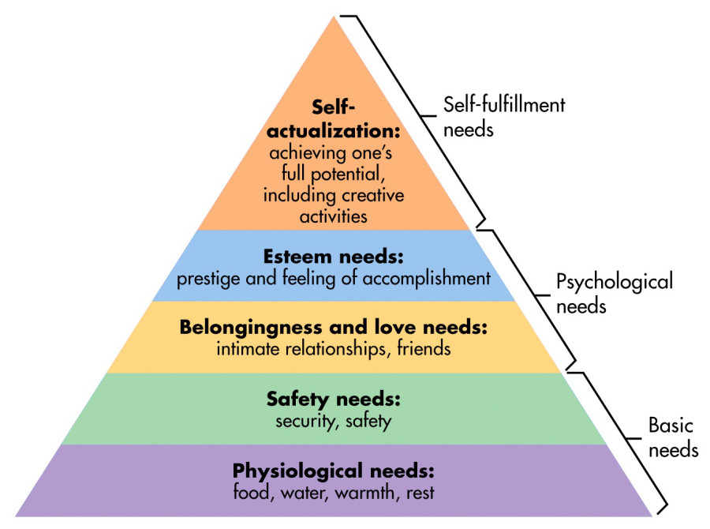

**Exercise:** How does the way we live our daily lives impact on our anxiety? Think about things such as sleep, diet, social support and so on?

**Creating a lifestyle that supports us in reducing and undermining anxiety:**

Just like children, as adults we thrive on a certain degree of routine and getting our basic needs met. This includes eating healthily, getting enough sleep, having social support and taking regular exercise.

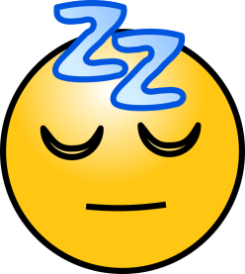**Getting a good night’s sleep**

Sleeping is much like eating, drinking and breathing; it is something that everyone does and it’s essential to our physical and mental health. Getting a good night’s sleep allows our bodies and minds to rest and re-energise. Here is a list of things that can contribute to your quality of sleep:

**BODY – Make sure you look after your body**

Caffeine – ideally we should try and stop drinking caffeine at least 4 hours before bed. This is because caffeine is a stimulant and can keep you up and includes tea, coffee, cola, energy drinks and chocolate.

Alcohol – although we may sometimes use alcohol to help us get off to sleep, it disrupts sleep later in the night, therefore stopping us from benefitting and getting a full restful sleep.

Food – try to avoid having a big or spicy meal late on in the evening. Also try not to go to bed hungry.

Exercise – try to do some exercise (around 30minutes) every day, to make your body feel tired.

**ENVIRONMENT – Make sure that your bedroom is a pleasant place to be**

Keep the bedroom clean and tidy.

Make sure the bedroom is cool (try to avoid extreme temperatures).

Ensure that you have a comfortable mattress, pillows and sheets.

Try to make the bedroom a quiet and dark environment (black-out blinds may help).

Introduce pleasant smells such as a drop of lavender oil on your pillow.

**ROUTINE – Having a bedtime routine helps teach us when it’s time to sleep.**

It’s best to keep to regular times for going to bed and getting up (even at the weekend!).

Avoid having naps in the day – no matter how tired you feel. Naps are going to keep the problem going by making it harder to get to sleep the next night.

Have at least an hour to unwind before bed – do something that makes you feel tired:

Have a soothing drink such as chamomile tea or something warm and milky.

Have a hot bath about 30 minutes before you go to bed.

Try a relaxation or breathing exercise before or when you go to bed.

Read a book.

**The 20-minute Rule**



Your bed is for sleeping, so if you find that you can’t sleep after around 20minutes:

1. Get up and go to another room.
2. If you have lots of thoughts racing through your mind, write them all down, and come back to them in the morning.
3. Engage in another quiet, relaxing activity e.g. reading. Do this activity until you feel tired and only return to bed when you feel sleepy.

If you still can’t sleep after a further 20minutes get up and repeat this routine again as many times as you need to throughout the night. This approach is called stimulus control training and it aims to break up any associations with feeling anxious, tense or worried with being in our beds.

**Healthy Eating:**

We all know about the basic dietary advice we are given about eating healthy, including eating 3 meals a day and eating plenty of fruit and vegetables.

What you may not know is that there is a whole branch of psychiatry that studies the link between what we eat and our mental wellbeing.

Eating a balanced and healthy diet gives our bodies including our brains the nutrients we need to function optimally, including producing all of chemicals such as hormones and neurotransmitters that keep our brain and nervous system functioning optimally. This has a direct impact on our emotional wellbeing.

Eating healthy and regular meals is also a way of making a definite decision to prioritise our wellbeing and look after ourselves. Preparing nutritious meals can give us a sense of achievement in addition to making our bodies feel more alive and less sluggish.

**Exercise:**

There is a proven link between regular exercise and mental wellbeing. Exercising for at least 30 minutes, at least 5 times a week is a good way of boosting both our physical and emotional wellbeing. This could be as simple as taking a brisk walk. You are more likely to do exercise regularly if you choose a form that you enjoy. There is also good evidence that taking exercise in the natural world has added benefits.

**Social Support and Connection:**

When we are anxious we can become so preoccupied with worry that we lose track of the people around us and don’t invest in our relationships. We may also feel irritable and impatient with the “demands” of others. However, good social support can help us keep perspective on our worries and help us relax and unwind. However anxious you are, do your best to invest in the relationships that are important to you. Don’t wait for people to reach out to you, even if you feel anxious reach out to others so that your connections are maintained.

**SMART Goals**

**S - SPECIFIC  
M - MEASURABLE  
A - ACHIEVABLE  
R - Relevant  
T -TIMED**

|  |  |
| --- | --- |
| Is it Specific? – are you aiming at just one, clear outcome? |  |
| Is it Measurable? – how would you know you’ve achieved your goal? |  |
| Is it Achievable? – make sure it is something that realistically can be done |  |
| Is it Relevant? – is it a goal that contributes to your broader objectives? |  |
| Is it Timed? – when do you want to achieve it by? |  |

We are more likely to succeed in reducing anxiety if we have a clear plan of action for how we are going to do this. SMART goals are a way of giving ourselves explicit action plans for what we are going to do and when. Each week on this course we will introduce a different “stream” of approaches and techniques that make up the overall approach to overcoming anxiety. We will invite you to make SMART goals relating to each stream that we introduce and to carry them out before the next session. You can also make additional SMART goals for what you want to achieve over the whole of the course, or part of the course.

When making your SMART goals you may wish to refer to the checklist below.

**Home Practice**

A person wearing a suit and tie

Description generated with very high confidence

In order to get the most from CBT it helps to practice at home.

**Summary of Session One:**

Key themes this week included an introduction to what anxiety is, how it impacts on our motivation, and how taking care of basic lifestyle choices is a good first step on the journey to overcoming anxiety.

Write down one or more key points that you have learnt today:

**Suggested Home Practice for Week One:**

You may wish to make SMART goals relating to lifestyle this week. The goals could focus on social contact, exercise, assisting yourself in getting good sleep or eating healthily.

Examples might include:

* I’m going to cook a balanced and healthy evening meal from scratch 5 out of 7 evenings this week. I will plan the meals in advance later this afternoon and buy the ingredients tomorrow morning.
* I will go for a 30 minute walk 5 days out of 7 this week. I will walk down to the beach and back after lunch. If the weather is bad, I’ll do a yoga session, watching a class on YouTube.
* I will phone my friend this evening and arrange to meet up for a coffee and a chat tomorrow afternoon.
* I will establish a sleep routine, starting tonight. I will go to bed at 10.00 p.m. and set my alarm for 6.30 a.m. I will read in the living room and do a relaxing breathing technique for 10 minutes before I go to my bedroom.

When setting your goals, you may want to use the checklist on page 15 to ensure that the goals are as “SMART” as they can be.

My SMART Goals for this week:

1)

2)

3)