**How to use Attend Anywhere to video call with your therapist**

**What is Attend Anywhere?**

Attend anywhere is a video calling system where you can speak to your therapist privately over the internet.

**What do I need to use it?**

* Attend Anywhere works on computers, laptops, tablets and phones that have a camera, speakers and a microphone.
* A good internet connection
* You also need to have either Google Chrome Image result for google chromeor Safari Image result for safari browserweb browser installed on your device.
* NOTE: Firefox and other browsers will not work. Please read the on-screen instructions and change browsers.

**How do I access it?**

Copy and paste this link into Chrome or Safari to open the system:

<https://nhsattend.vc/s2w-dorset-HI-intensity-therapy-and-counselling>

You will need to enter some basic information, test if everything is working, and then you are ready to go.

**How do I use it?**

It is really easy but if would like to learn more you can watch this video by clicking on this link: <https://www.youtube.com/watch?v=YR00Gorwq3U>

You can also search ‘How to use attend anywhere’ on YouTube (the picture below shows what the video looks like – it is usually the first one that comes up).

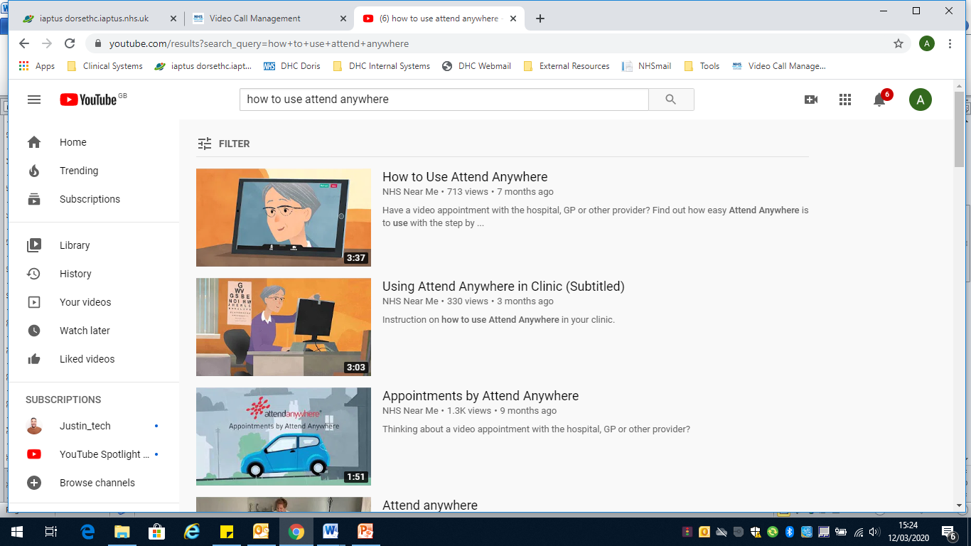

**Some top tips for using the system:**

* You can test the system out before the call to make sure that everything works. Click on the link: <https://nhsattend.vc/s2w-dorset-HI-intensity-therapy-and-counselling> and then click the “Test” button.
* If you cannot get the system to work then please call 0300 123 1120 or email dhc.s2w.pped.admin@nhs.net and let us know so that we can help
* Make sure that the place you call from is private, quiet and well lit
* Please wait for your therapist to connect to your call and don’t leave the waiting room. They may be running late so keep the connection open for them
* If the signal starts to break up then press the refresh button at the top of the screen and this will reconnect you and may improve things.