Iaptus Video is a secure video call service for patients with pre-arranged appointment times only. Please speak to the service about your interest in having your appointments via video conferencing.

It is recommended you use Iaptus video on a PC, Mac, using a Google Chrome browser. Iaptus Video will not work on Internet Explorer .
You can download Google Chrome for free.

It is also possible to access using a mobile device, however we would not recommend this. After clicking the link to the video consultation you will be prompted to download the Jitsi Meet app, which is available for free via Google Play and the iOS App store. Steps to Wellbeing is in no way affiliated with Jitsi, and downloading this application is at your own risk.

The video call is free (except your internet usage charge) and data is not used whilst you are in the waiting room. –***** It’s not free if on a mobile?*****
Integrated Video Guide
At the time of your appointment please open the link provided in the email in Google Chrome or in the Jitsi app.
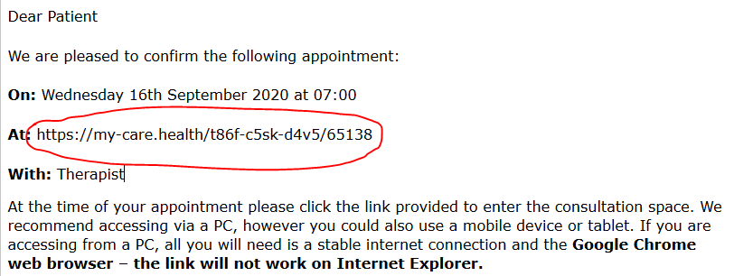

Video session view

Once started, the session screen provides audio and video controls:
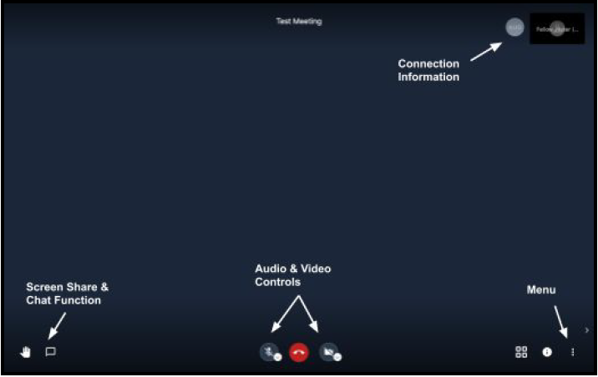
Tip: Ensure you allow Chrome access to your camera and microphone when prompted.

You will then see yourself in the main part of the screen and also a three word sentence at the top of the screen which is unique to your call. WHAT IS THE 3 WORD SENTENCE FOR?
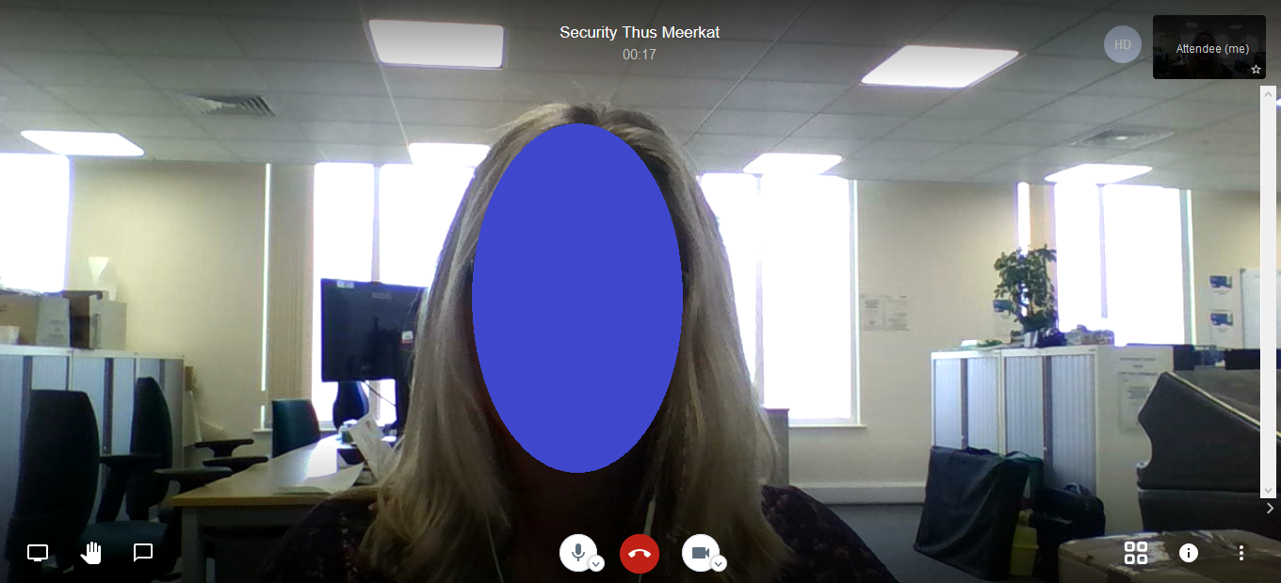

When the consultation is ready to begin, your image will shrink and move to the corner of the screen and you will see your clinician.
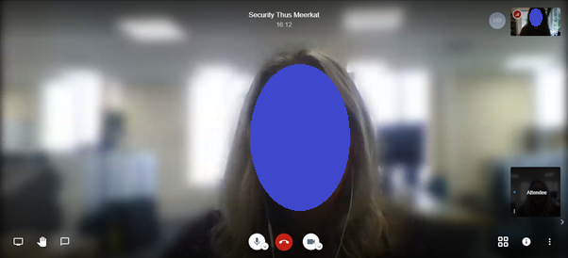
Click Settings Option from the menu

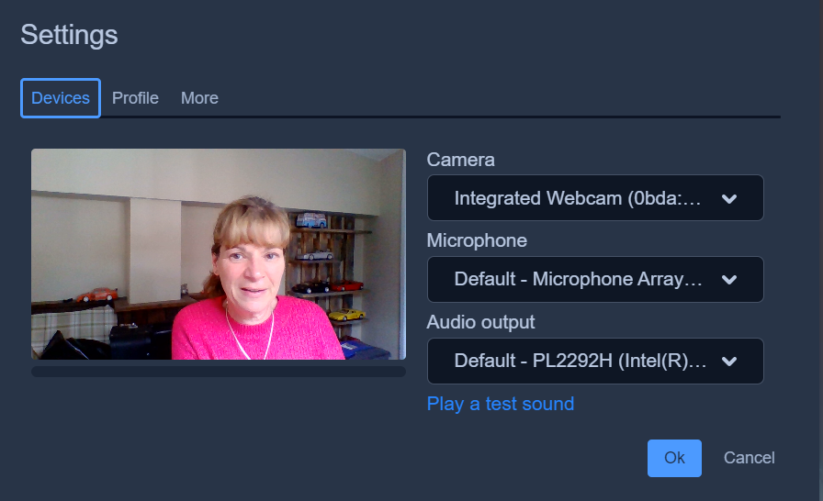
Click Device

Change your display name from Attendee to your name.
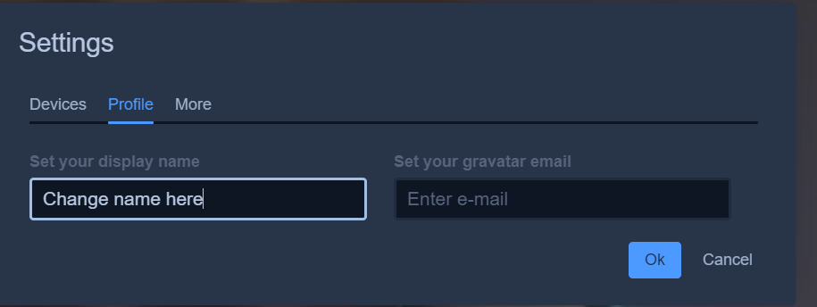

Change View

You can choose to view of your screen either to have your therapist as a whole screen or 2 screens next to each other.
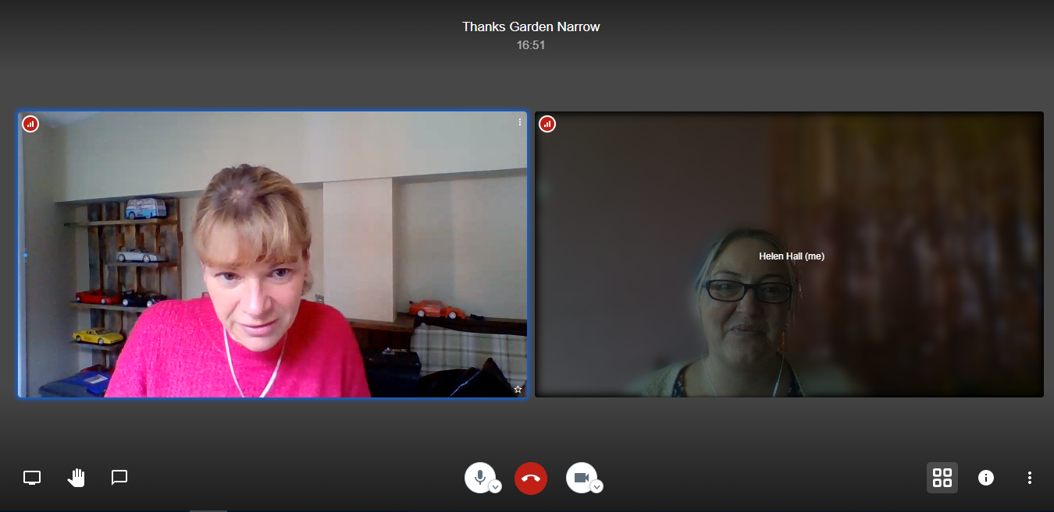
Click to change screen view

Raise hand option
A Blue hand will show in the corner of the screen

To raise a hand to ask a question.

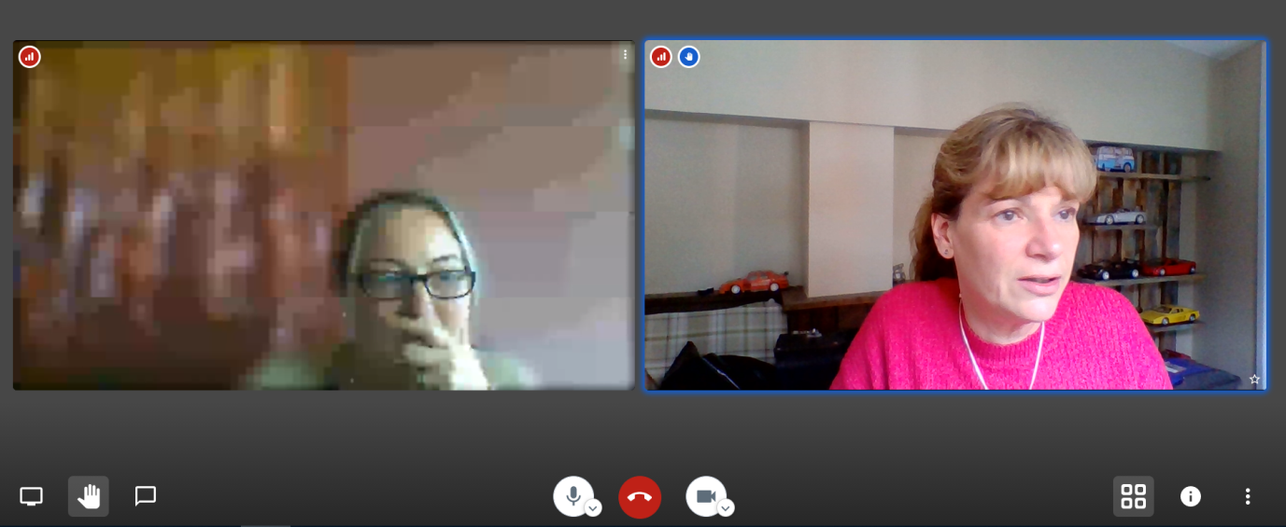

Click to Raise/Lower your hand

Chat Option

If you are able to see your therapist but not able to hear them you can communicate through the chat facility.

Click here to open/close chat

Share screen Option

It is possible to share information from your computer with your therapist.

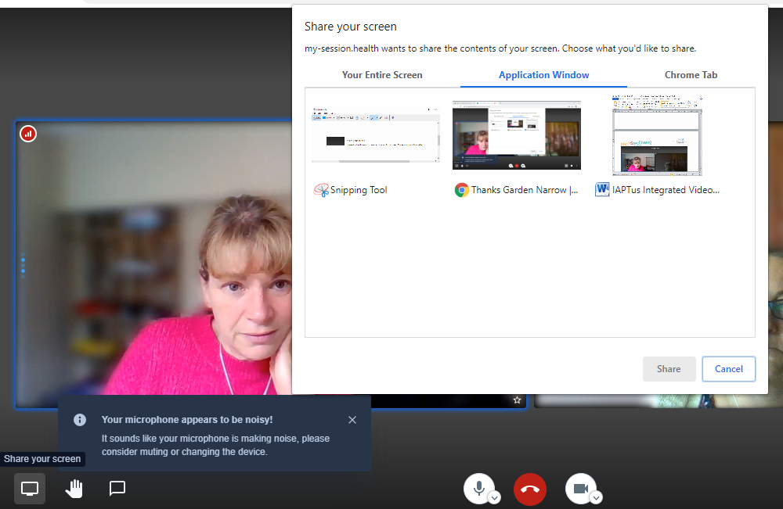
Choose the screen/document you would like to share
Click to share screen

Connection Quality

If you have a poor connection (denoted by the red circle with white bars) try moving closer to the WiFi box or plug in using an Ethernet cable.

You can also adjust your video quality to improve your connection; this can be done through the Manage Video Quality option in the menu

