Go To Meeting Tips
This document contains some tips and hints based on the feedback of people using the system. Feel free to e-mail (Andrew.o’neill1@nhs.net ) or send me a message on Teams if you have some more to add.

Tip 1: Never double click on the Go To Meeting icon on your desktop to start the programme.
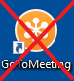
This is the most common problem people are having! There are a few issues caused by this:
- If you go in properly through the website then one leader can START the meeting and the other leader can JOIN. But if both leaders go in by double clicking the icon then the software sees this as both leaders starting the meeting and it causes problems like locking a leader out or shutting down the meeting.
- By going in through the desktop icon you cannot select which meeting to start and you may start the wrong meeting and not be able to find your clients.
- You can’t create and edit your meetings if you go in this way
- You can’t sign out if you go in this way.

Solution: Always go into Go To Meeting through the website. Click on https://www.gotomeeting.com/en-gb

Tip 2: Always sign out
If you have logged in properly through the website then you will be able to sign out through the website after you are finished your session. Click on the circle (top right), and click sign out.

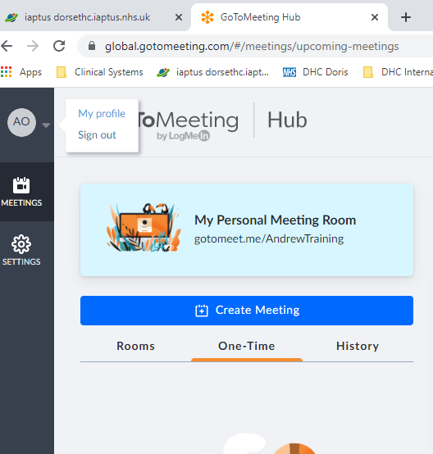

Tip 3: Reuse your old meeting.
Every time you create a new meeting in Go To Meeting the link to the meeting changes. This means that you need to send out a new link every week. This is not ideal as (1) it is extra work for you and (2) there is a chance that the client will click on the wrong link. This tip is a work around for this but you need to do it immediately after the meeting finishes or otherwise the meeting will disappear into history before you can change it.
After you have finished your meeting click Edit and change the date to the next meeting date. This way your link will stay the same for every session of the group as you keep reusing the same meeting.

Tip 4: One leader STARTS, the other leader JOINS the meeting.
You can both login with the account details but it is important that one person STARTS and the other person JOINS. Decide in advance who is going to start the meeting. That person clicks on the correct meeting and then clicks the START button.
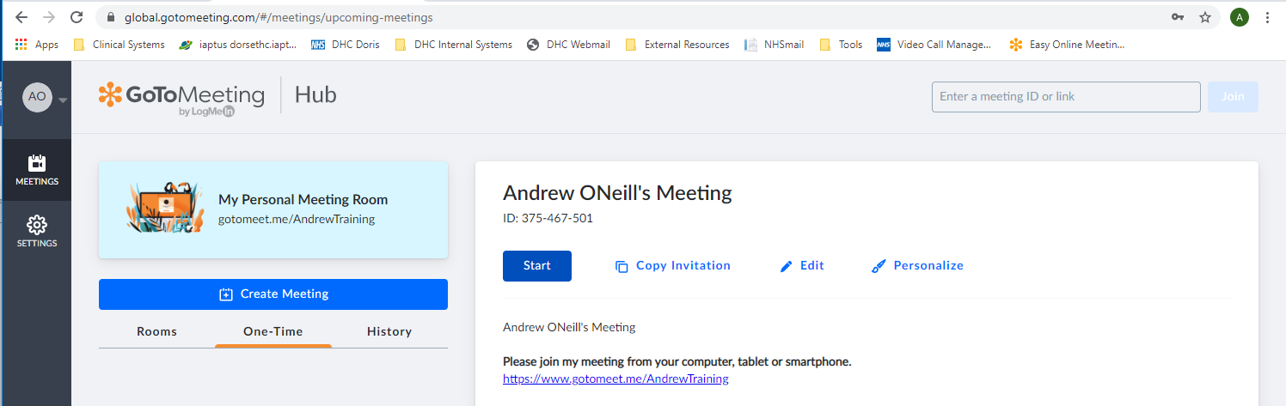

Any other leaders would click on the correct meeting (left hand side) and then click the JOIN button.
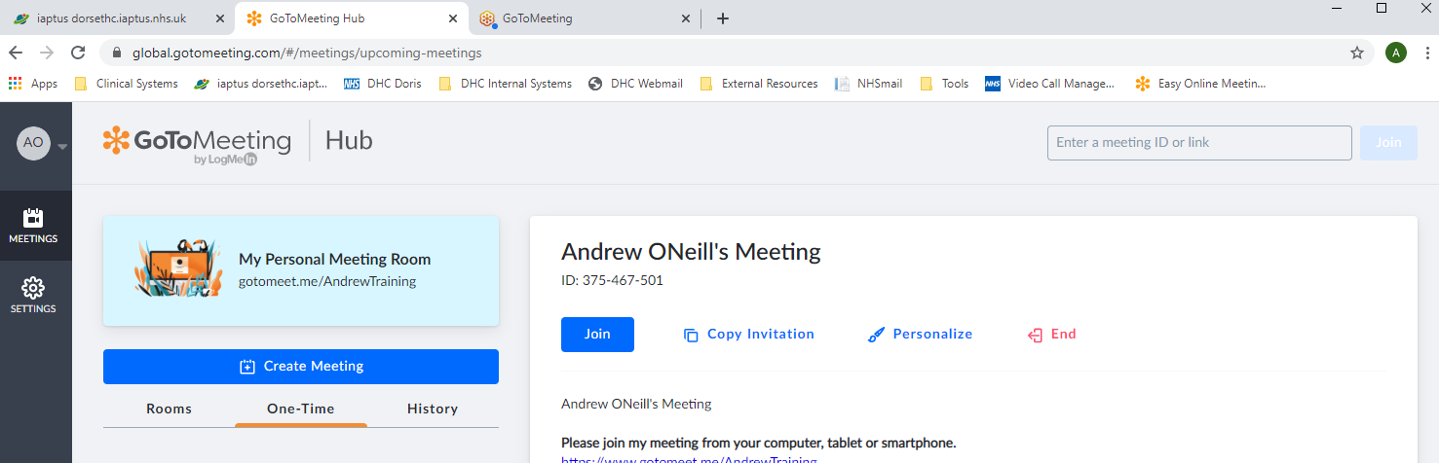

Tip 5: Making your second presenter the organiser
If the other person logs in as a client then you can still make them an organiser by right clicking on their name in the “Attendees” section and selecting “Make organiser”. You don’t need to do this if you follow Tip 4 as you will both be organisers if you both login with the username and password and have one person START and one person JOIN.

Tip 6: Booking MDS contacts with Hazel.
Hazel Mackrell has kindly offered to put the short MDS contacts onto IAPTUS for the online groups. She has an excel document on Sentinel House drive where you can fill in your group details (give her about a week’s notice) and she will input the short MDS contacts onto IAPTUS for you.

The Excel document can be found at:
Sentinel House (N:) -> IAPT Rescources -> Webinar -> “Webinar red contacts and MDS Request”

Tip 7: You can edit the meeting bookings while groups are running:
A number of people have been concerned about logging into Go To Meeting and creating groups while other people are running a group. There is no limit to the number of people allowed onto the website to make changes here. The problems only occur when too many people try and START or JOIN live meetings. Also see tip 1-> NEVER double click on the desktop icon if you are looking to edit a group – always click on the website link and go in that way.

Tip 8: Meetings have to be started on a laptop. You cannot start/run a meeting on a phone or a tablet, but you can join the meetings with these devices. If you don’t have a laptop then get your group assistant to start the meeting and join it once they have started it.

Tip 9 : Changing your name on Go To Meeting
If you would like to change your name so that it doesn’t show up as “Dorset Healthcare” then you can do this by right clicking on your account under Attendees and then clicking on “Edit Your Name and Email…” A box will pop up giving you the option to change you name. Make sure that the “Remember name and email” box is unchecked – this means that it won’t save your name and when the next leader logs in and it will ask them what name they want to use.

